**Optimisation Algorithms for Data Analysis Week 2 Assignment**

Jiaming Deng 22302794

**a (i)** Firstly I used sympy to define the function required in the question, and next I used sympy's function to find the derivative.

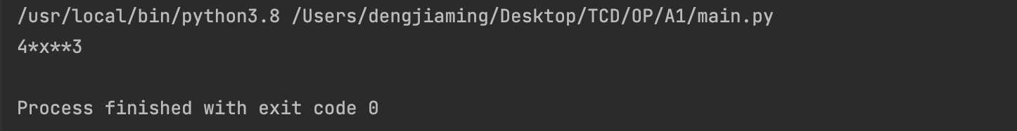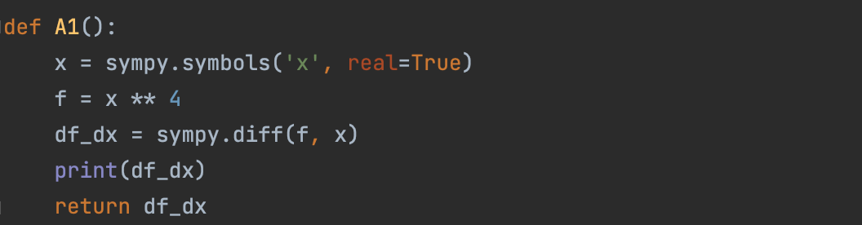

**a (ii)** Firstly I call the previous method to get derivative expression of the function. Next I get the finite difference by $\frac{f(x+δ) − f(x)}{δ}$. Finally I use numpy to generate a large range of points and plot them out. I find that they are basically equal.

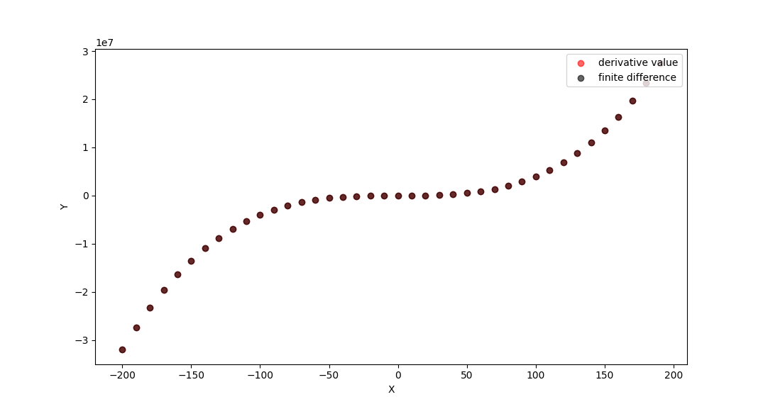

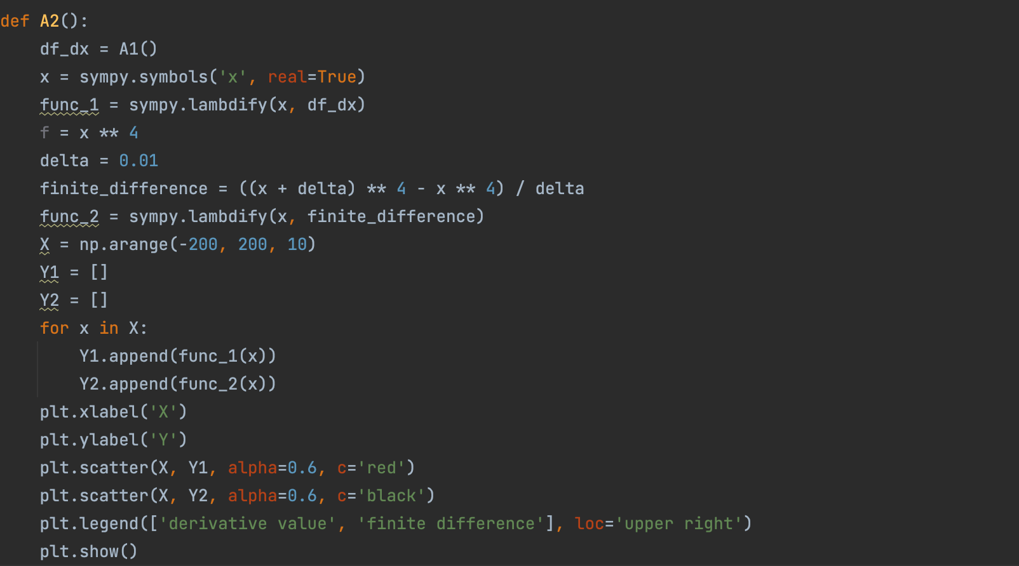

**a (iii)** The image is obtained by modifying the value of delta in the previous problem and plotting the points. I find that the larger the delta, the greater the difference between the finite difference estimate and the data obtained from the derivative. The smaller the delta, the closer the finite difference estimate is to the true result. This is because the finite difference estimate estimates the derivative of a curve at a point on the curve by taking the point on the curve and the point that differs by delta from the horizontal coordinate of that point and calculating the slope of the line through those two points. The derivative is defined as the slope of the line tangent to the curve at a point on the curve. Therefore the greater the delta, the greater the difference between the two points taken and the less accurate the derivative is.

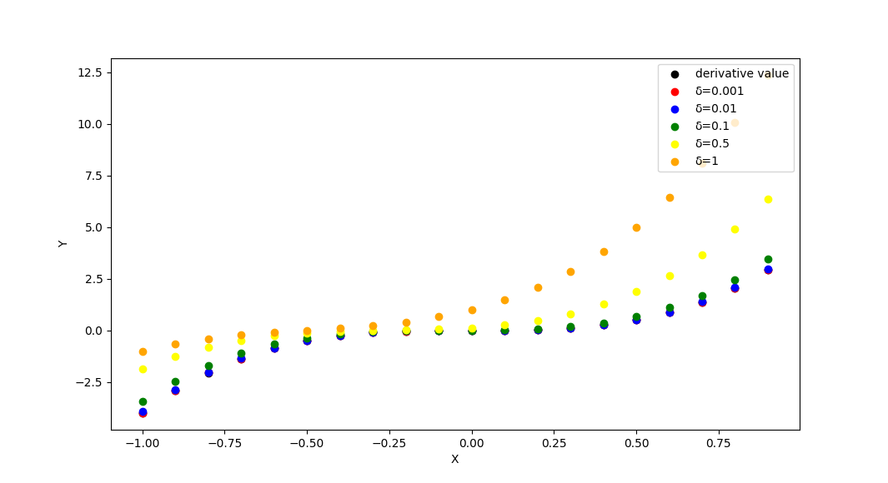

**b(i)** Firstly the inputs to the function are the expression, the derivative of the expression, the point at which gradient descent begins, a fixed step size alpha, and the number of iterations. Next, two arrays are created, X records the position of each x and F records the value of f(x) at the time. Finally X and F are returned.

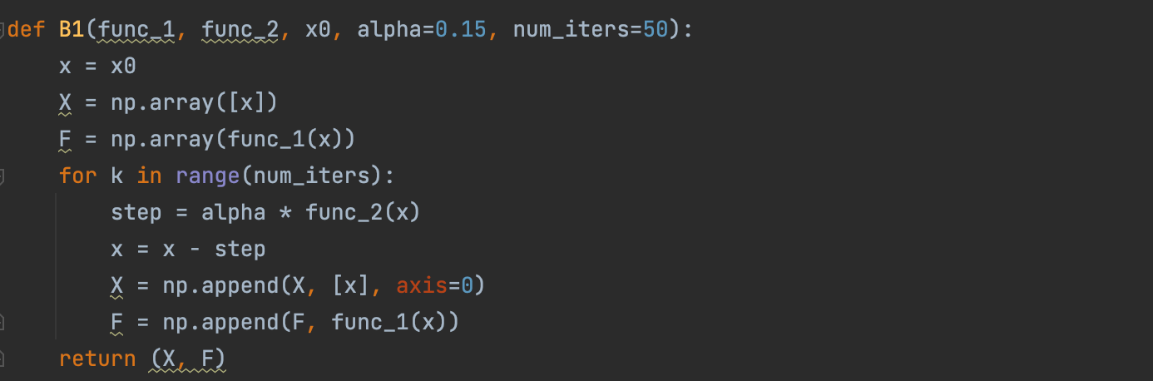

**b (ii)** I initial value x = 0.1 and step size alpha = 0.1 and run my gradient descent function with the function y = $x^{4}$. The first and second graphs show the change in the values of f(x) and x as the number of iterations increases, respectively. The third graph plots the expressions corresponding to and plots the gradient descent on the same graph for easy comparison. The drop in f(x) is very large within the first 5 iterations of the gradient descent and is almost constant from about the 7th iteration. During the first 2 iterations, x decreases by half, and then the decrease gradually slows down. Thus the gradient decreases the most in the first 2 iterations and remains almost constant from about the 7th.

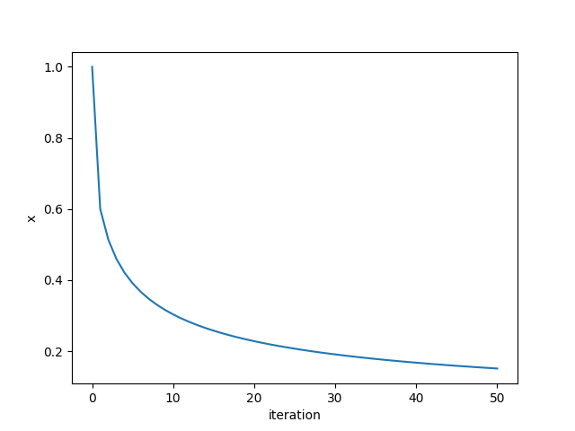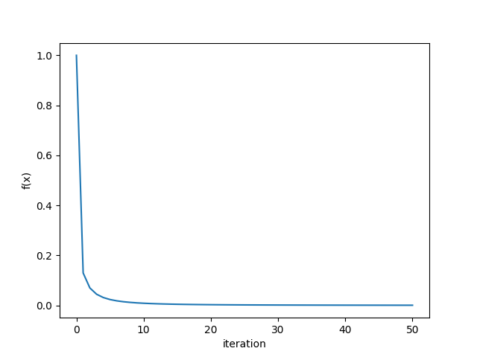

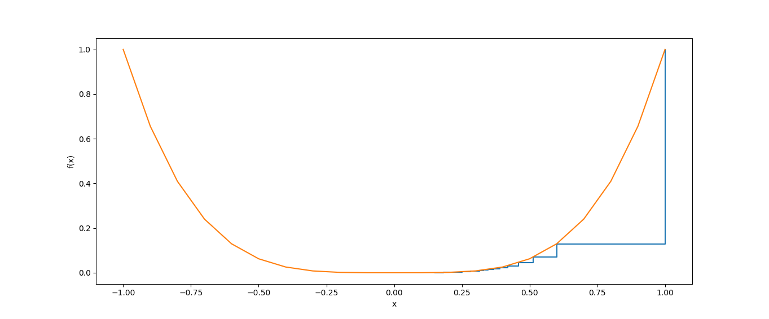

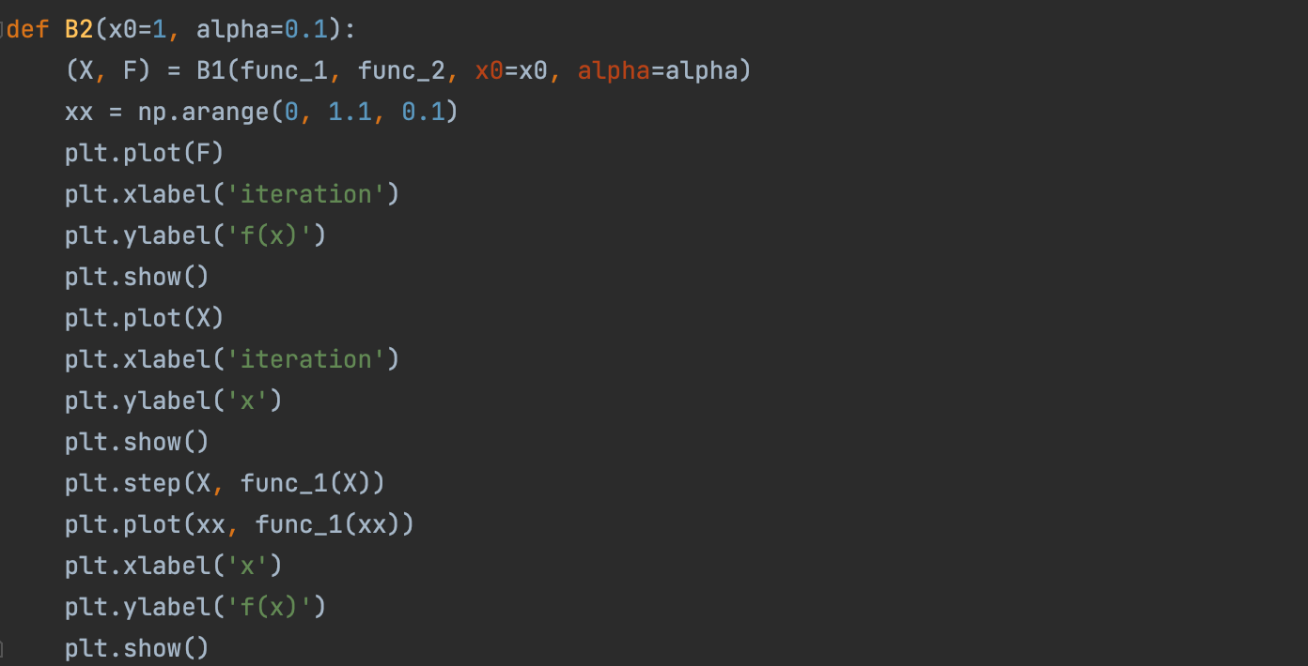

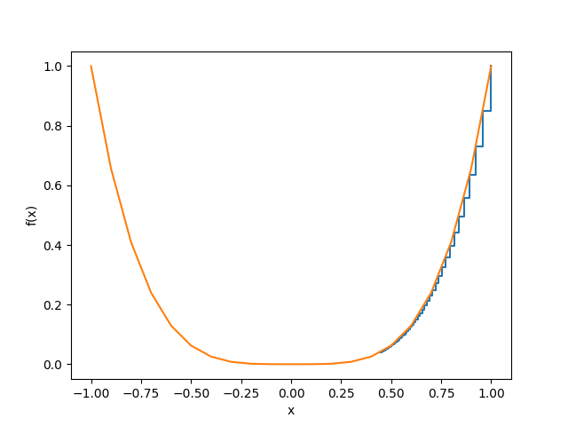**b (iii)** Firstly I choose 0.01, 0.1, 0.2 and 0.5 as the values of alpha and obtain four plots as follows. I find that as alpha increases, the rate of gradient descent increases, because as alpha increases, x changes more with each iteration, as the expression $f(x)=x^{4}$, x decreases more significantly as it’s larger. When alpha >= 0.5, the plot behaviors non-convergence because it’s too large for the alpha.

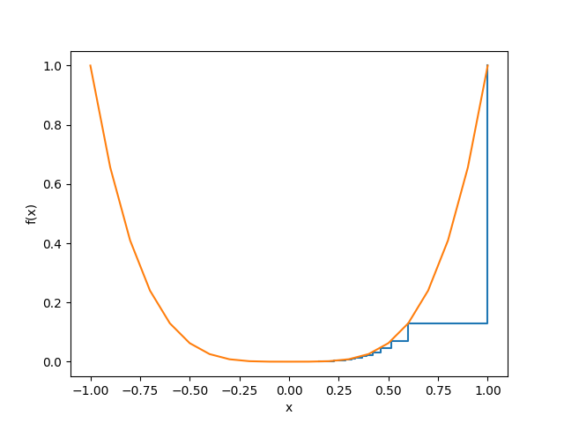

figure 1 figure 2

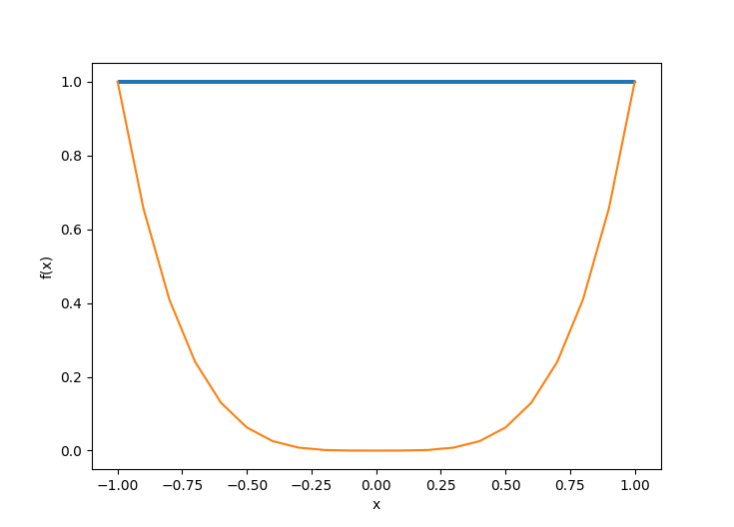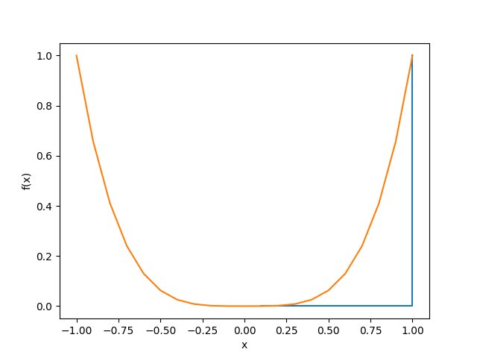

figure 3 figure 4

Next, I choose 0.5, 0.6, 0.7, 0.8, 0.9 as the values of x and obtain five plots as below. As the x increase, the gradient has dropped faster. Because the derivative of an expression increases as x increases, the derivative is a parameter that reflects the rate of change of the function. Therefore the larger x is, the faster the gradient falls.

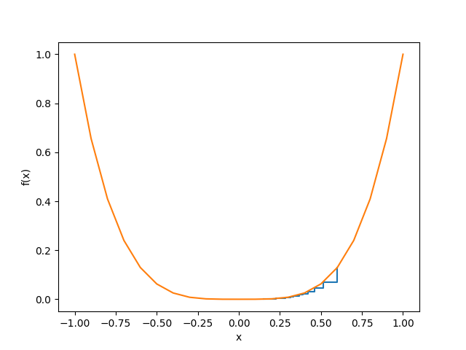

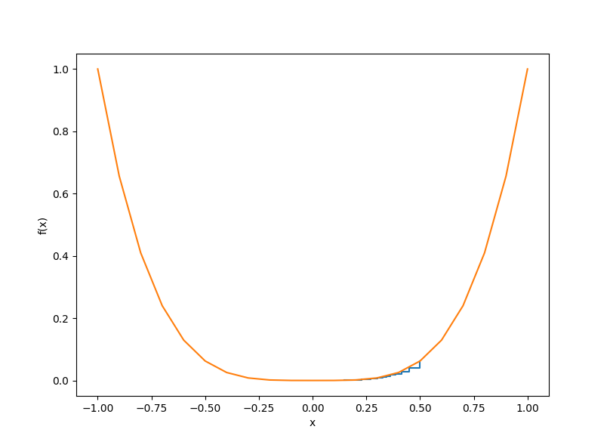

figure 1 figure 2

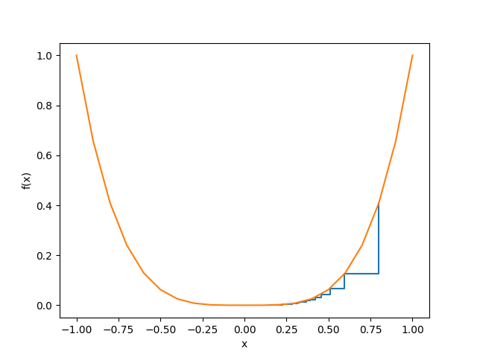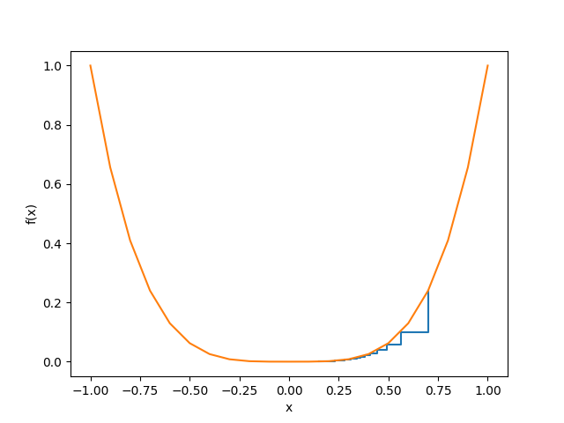

figure 3 figure 4

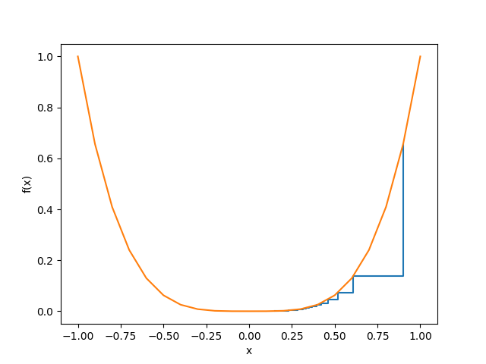

figure 5

**c (i)** Firstly I fix alpha = 0.1 and choose gamma to be 0.1, 0.5, 1, 2, respectively, to obtain the expression curve with gradient descent as follows. The larger gamma is, the convergence of the gradient descent more like to perform non-convergence because larger gamma means larger derivative.

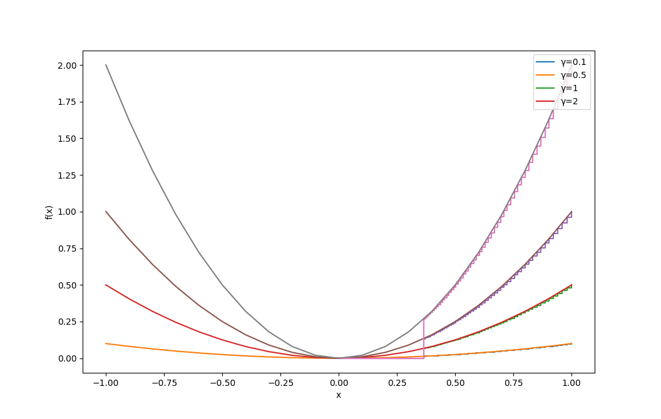

**c (ii)** Firstly I fix alpha = 0.1 and choose gamma to be 0.1, 0.5, 1, 2, respectively, to obtain the expression curve with gradient descent as follows. The derivative of the express is purely depend by gamma, so the larger the gamma is, the convergence of the gradient descent more like to perform non-convergence.

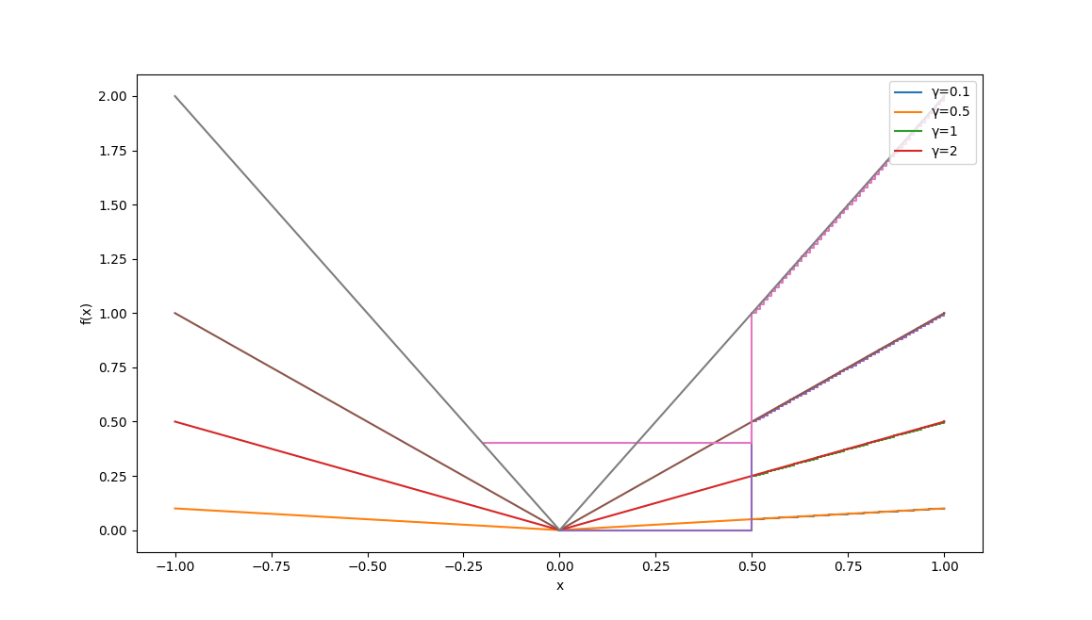

**Appendix**

1. **import** sympy
2. **import** numpy as np
3. **import** matplotlib
5. matplotlib.use('TkAgg')
6. **import** matplotlib.pyplot as plt

9. **def** A1():
10. x = sympy.symbols('x', real=True)
11. f = x ** 4
12. df_dx = sympy.diff(f, x)
13. **print**(df_dx)
14. **return** df_dx

17. **def** A2():
18. df_dx = A1()
19. x = sympy.symbols('x', real=True)
20. func_1 = sympy.lambdify(x, df_dx)
21. f = x ** 4
22. delta = 0.01
23. finite_difference = ((x + delta) ** 4 - x ** 4) / delta
24. func_2 = sympy.lambdify(x, finite_difference)
25. X = np.arange(-200, 200, 10)
26. Y1 = []
27. Y2 = []
28. **for** x **in** X:
29. Y1.append(func_1(x))
30. Y2.append(func_2(x))
31. plt.xlabel('X')
32. plt.ylabel('Y')
33. plt.scatter(X, Y1, alpha=0.6, c='red')
34. plt.scatter(X, Y2, alpha=0.6, c='black')
35. plt.legend(['derivative value', 'finite difference'], loc='upper right')
36. plt.show()

39. **def** A3():
40. df_dx = A1()
41. x = sympy.symbols('x', real=True)
42. func_1 = sympy.lambdify(x, df_dx)
43. f = x ** 4
44. X = np.arange(-1, 1, 0.1)
46. delta = 0.001
47. finite_difference = ((x + delta) ** 4 - x ** 4) / delta
48. func_2 = sympy.lambdify(x, finite_difference)
50. delta = 0.01
51. finite_difference = ((x + delta) ** 4 - x ** 4) / delta
52. func_3 = sympy.lambdify(x, finite_difference)
54. delta = 0.1
55. finite_difference = ((x + delta) ** 4 - x ** 4) / delta
56. func_4 = sympy.lambdify(x, finite_difference)
58. delta = 0.5
59. finite_difference = ((x + delta) ** 4 - x ** 4) / delta
60. func_5 = sympy.lambdify(x, finite_difference)
62. delta = 1
63. finite_difference = ((x + delta) ** 4 - x ** 4) / delta
64. func_6 = sympy.lambdify(x, finite_difference)
66. Y1 = []
67. Y2 = []
68. Y3 = []
69. Y4 = []
70. Y5 = []
71. Y6 = []
72. **for** x **in** X:
73. Y1.append(func_1(x))
74. Y2.append(func_2(x))
75. Y3.append(func_3(x))
76. Y4.append(func_4(x))
77. Y5.append(func_5(x))
78. Y6.append(func_6(x))
79. plt.xlabel('X')
80. plt.ylabel('Y')
81. plt.scatter(X, Y1, c='black')
82. plt.scatter(X, Y2, c='red')
83. plt.scatter(X, Y3, c='blue')
84. plt.scatter(X, Y4, c='green')
85. plt.scatter(X, Y5, c='yellow')
86. plt.scatter(X, Y6, c='orange')
87. plt.legend(['derivative value', 'δ=0.001', 'δ=0.01', 'δ=0.1', 'δ=0.5', 'δ=1'], loc='upper right')
88. plt.show()

91. **def** func_1(x):
92. **return** x ** 4

95. **def** func_2(x):
96. **return** 4*x**3

99. **def** func_3(x, gamma):
100. **return** gamma*x**2

103. **def** func_4(x, gamma):
104. **return** gamma*2*x

107. **def** func_5(x, gamma):
108. **return** gamma*abs(x)

111. **def** func_6(x, gamma):
112. **if** x < 0:
113. **return** -gamma
114. **return** gamma

117. **def** B1(func_1, func_2, x0, alpha=0.15, num_iters=50):
118. x = x0
119. X = np.array([x])
120. F = np.array(func_1(x))
121. **for** k **in** range(num_iters):
122. step = alpha * func_2(x)
123. x = x - step
124. X = np.append(X, [x], axis=0)
125. F = np.append(F, func_1(x))
126. **return** (X, F)

129. **def** B2(x0=1, alpha=0.1):
130. (X, F) = B1(func_1, func_2, x0=x0, alpha=alpha)
131. xx = np.arange(-1, 1.1, 0.1)
132. # plt.plot(F)
133. # plt.xlabel('iteration')
134. # plt.ylabel('f(x)')
135. # plt.show()
136. # plt.plot(X)
137. # plt.xlabel('iteration')
138. # plt.ylabel('x')
139. # plt.show()
140. plt.step(X, func_1(X))
141. plt.plot(xx, func_1(xx))
142. plt.xlabel('x')
143. plt.ylabel('f(x)')
144. plt.show()

147. **def** B3():
148. **for** x **in** np.arange(0.5, 1, 0.1):
149. B2(x, alpha=0.1)
150. # for alpha in [0.01, 0.1, 0.2, 0.5]:
151. #     B2(1, alpha=alpha)

154. **def** C1():
155. gamma = 0.1
156. x = 1
157. X_1 = np.array([x])
158. F_1 = np.array(func_3(x, gamma))
159. **for** k **in** range(50):
160. step = 0.1 * func_4(x, gamma)
161. x = x - step
162. X_1 = np.append(X_1, [x], axis=0)
163. F_1 = np.append(F_1, func_3(x, gamma))
165. gamma = 0.5
166. x = 1
167. X_2 = np.array([x])
168. F_2 = np.array(func_3(x, gamma))
169. **for** k **in** range(50):
170. step = 0.1 * func_4(x, gamma)
171. x = x - step
172. X_2 = np.append(X_1, [x], axis=0)
173. F_2 = np.append(F_1, func_3(x, gamma))
175. gamma = 1
176. x = 1
177. X_3 = np.array([x])
178. F_3 = np.array(func_3(x, gamma))
179. **for** k **in** range(50):
180. step = 0.1 * func_4(x, gamma)
181. x = x - step
182. X_3 = np.append(X_1, [x], axis=0)
183. F_3 = np.append(F_1, func_3(x, gamma))
185. gamma = 2
186. x = 1
187. X_4 = np.array([x])
188. F_4 = np.array(func_3(x, gamma))
189. **for** k **in** range(50):
190. step = 0.1 * func_4(x, gamma)
191. x = x - step
192. X_4 = np.append(X_1, [x], axis=0)
193. F_4 = np.append(F_1, func_3(x, gamma))
195. xx = np.arange(-1, 1.1, 0.1)
197. plt.plot(F_1)
198. plt.plot(F_2)
199. plt.plot(F_3)
200. plt.plot(F_4)
201. plt.xlabel('iteration')
202. plt.ylabel('f(x)')
203. plt.show()
205. plt.plot(X_1)
206. plt.plot(X_2)
207. plt.plot(X_3)
208. plt.plot(X_4)
209. plt.xlabel('iteration')
210. plt.ylabel('x')
211. plt.show()
213. plt.step(X_1, func_3(X_1, 0.1))
214. plt.plot(xx, func_3(xx, 0.1))
215. plt.step(X_2, func_3(X_2, 0.5))
216. plt.plot(xx, func_3(xx, 0.5))
217. plt.step(X_3, func_3(X_3, 1))
218. plt.plot(xx, func_3(xx, 1))
219. plt.step(X_4, func_3(X_4, 2))
220. plt.plot(xx, func_3(xx, 2))
221. plt.xlabel('x')
222. plt.ylabel('f(x)')
223. plt.legend(['γ=0.1', 'γ=0.5', 'γ=1', 'γ=2'], loc='upper right')
224. plt.show()

227. **def** C2():
228. gamma = 0.1
229. x = 1
230. X_1 = np.array([x])
231. F_1 = np.array(func_5(x, gamma))
232. **for** k **in** range(50):
233. step = 0.1 * func_6(x, gamma)
234. x = x - step
235. X_1 = np.append(X_1, [x], axis=0)
236. F_1 = np.append(F_1, func_5(x, gamma))
238. gamma = 0.5
239. x = 1
240. X_2 = np.array([x])
241. F_2 = np.array(func_5(x, gamma))
242. **for** k **in** range(50):
243. step = 0.1 * func_6(x, gamma)
244. x = x - step
245. X_2 = np.append(X_1, [x], axis=0)
246. F_2 = np.append(F_1, func_5(x, gamma))
248. gamma = 1
249. x = 1
250. X_3 = np.array([x])
251. F_3 = np.array(func_5(x, gamma))
252. **for** k **in** range(50):
253. step = 0.1 * func_6(x, gamma)
254. x = x - step
255. X_3 = np.append(X_1, [x], axis=0)
256. F_3 = np.append(F_1, func_5(x, gamma))
258. gamma = 2
259. x = 1
260. X_4 = np.array([x])
261. F_4 = np.array(func_5(x, gamma))
262. **for** k **in** range(50):
263. step = 0.1 * func_6(x, gamma)
264. x = x - step
265. X_4 = np.append(X_1, [x], axis=0)
266. F_4 = np.append(F_1, func_5(x, gamma))
268. xx = np.arange(-1, 1.1, 0.1)
269. plt.plot(F_1)
270. plt.plot(F_2)
271. plt.plot(F_3)
272. plt.plot(F_4)
273. plt.xlabel('iteration')
274. plt.ylabel('f(x)')
275. plt.show()
277. plt.plot(X_1)
278. plt.plot(X_2)
279. plt.plot(X_3)
280. plt.plot(X_4)
281. plt.xlabel('iteration')
282. plt.ylabel('x')
283. plt.show()
285. plt.step(X_1, func_5(X_1, 0.1))
286. plt.plot(xx, func_5(xx, 0.1))
287. plt.step(X_2, func_5(X_2, 0.5))
288. plt.plot(xx, func_5(xx, 0.5))
289. plt.step(X_3, func_5(X_3, 1))
290. plt.plot(xx, func_5(xx, 1))
291. plt.step(X_4, func_5(X_4, 2))
292. plt.plot(xx, func_5(xx, 2))
293. plt.xlabel('x')
294. plt.ylabel('f(x)')
295. plt.legend(['γ=0.1', 'γ=0.5', 'γ=1', 'γ=2'], loc='upper right')
296. plt.show()

299. **if** __name__ == '__main__':
300. C1()